**Program 1: (Commands)**

**1. tcpdump** – Capture network packets

**Command:** sudo tcpdump

**Output:**

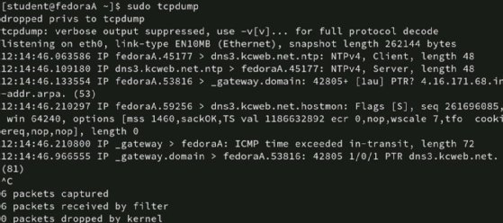

**2. netstat** – View network connections and ports

**Command:** netstat -an

**Output:**

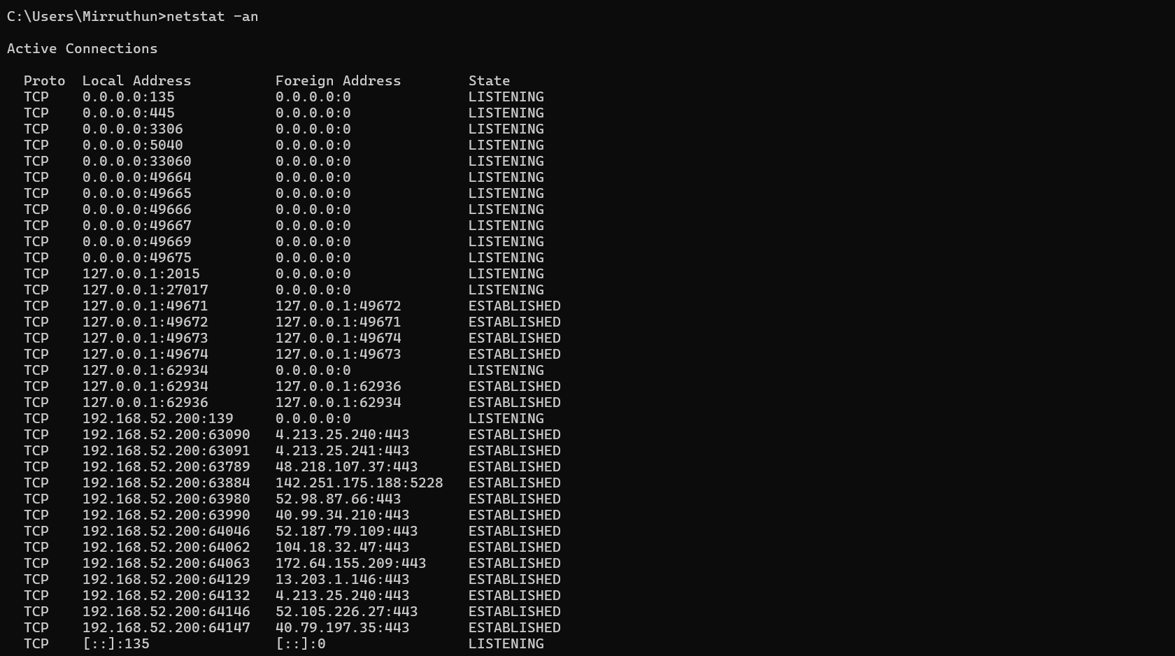

**3. ifconfig** – Configure/view network interfaces

**Command:** ipconfig

**Output:**

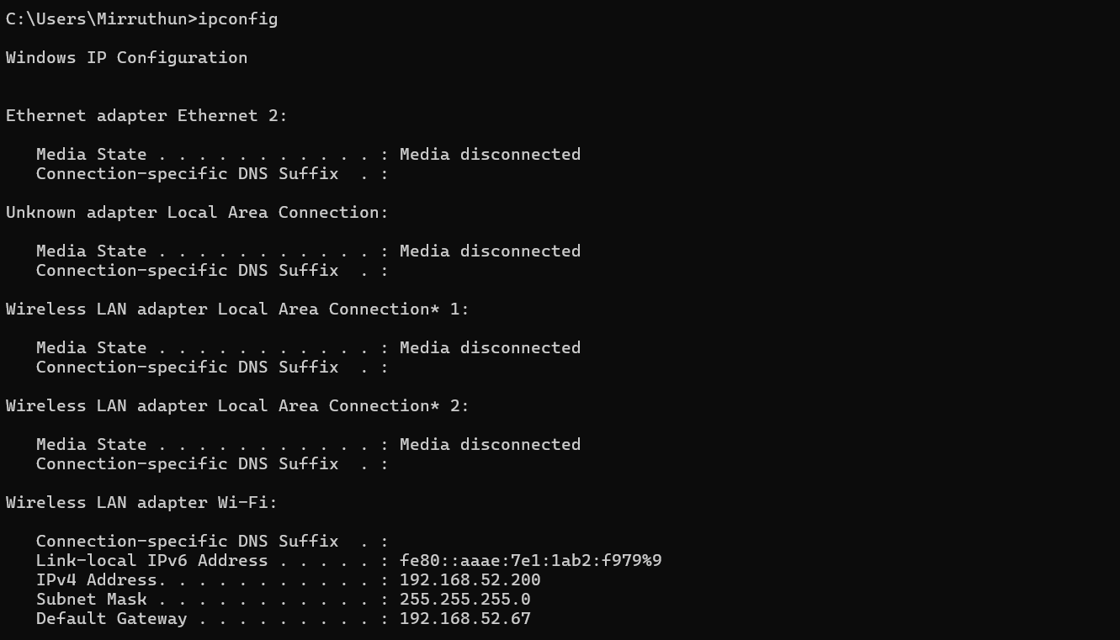

**4. nslookup** – DNS lookup

**Command:** nslookup google.com

**Output:**

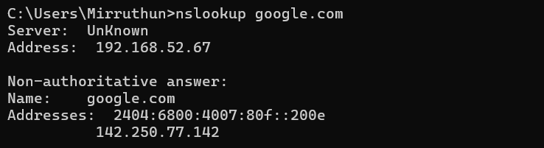

**5. traceroute** – Trace network path to destination

**Command:** tracert google.com

**Output:**

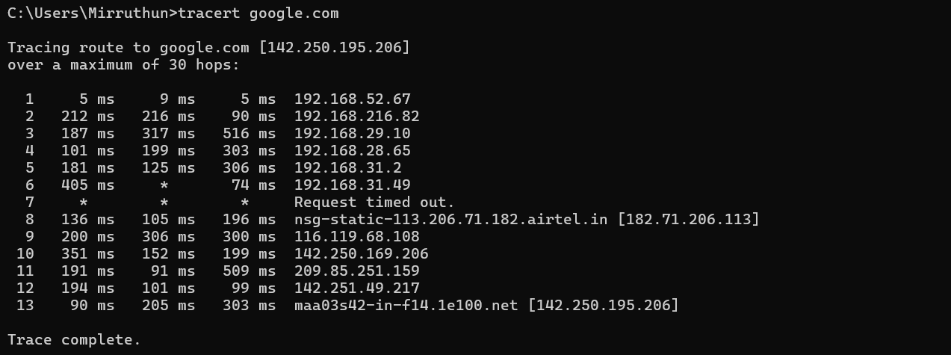

**6. ping** - Verifies IP-level connectivity to another TCP/IP computer by sending Internet Control Message Protocol (ICMP) Echo Request messages. The receipt of corresponding Echo Reply messages are displayed, along with round-trip times. Ping is the primary TCP/IP command used to troubleshoot connectivity, reachability, and name resolution. RESULT: Thus the TCP/IP network command

**Command:** ping espn.com

**Output:**

